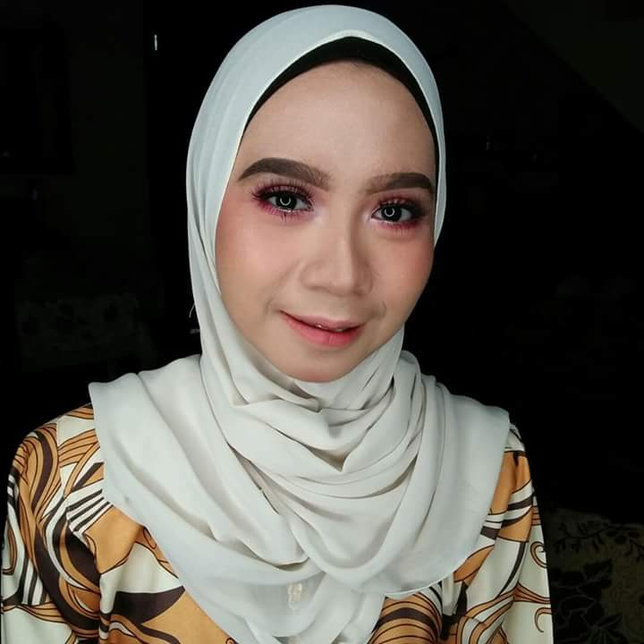

NURSYAFIQAH BINTI SHAMSUDIN

No 152 Jalan 8/4B Bandar Tasik Kesuma,

43700 Beranang, Selangor

HP: 0172572428

E-MAIL: qaqaluereyqa@gmail.com

|  |  |  |
| --- | --- | --- |
|  | Education |  |

**DIPLOMA IN MOBILE TECHNOLOGY**

Ampang Community College

2018

|  |
| --- |
| **CERTIFICATE IN**  **APPLICATION COMPUTER**  Hulu Langat  Community College  2016  **SIJIL PELAJARAN MALAYSIA**  SMK Bandar Tasik Kesuma  2012 |

|  |  |  |
| --- | --- | --- |
|  | Work Experience |  |
|  |  |

**JOBTITLE. COMPANY. DATES FROM – TO**

* 3F RESOURCES SDN BHD from November 2015 till December 2015
* ICT Junior Technician at Data Plus Marketing from January 2016 till February 2016

|  |  |  |
| --- | --- | --- |
|  | Personal Strenght |  |
|  |  |

Have a good sense of a teamwork but also to handle work independently. Love challenges and willing to upgrade skills and knowledge. Confident, flexible and able to solve problems creatively. Willing to accept criticism and easily adapt in new environment.

|  |  |  |
| --- | --- | --- |
|  | Key Skill |  |
|  |  |

**LANGUAGE :**

* Bahasa Inggeris 8/10
* Bahasa Melayu 10/10

**COMPUTER SKILLS :**

* Microsoft Office (Words, PowerPoint, Excel)
* Microsoft Access
* Adobe Photoshop
* Adobe Illustrator

**COMPETENT IN:**

* Mobile Device Repairing
* Graphics Design
* Develop Apps
* Telecommunication and Network

**ACHIEVEMENT**

**(Description/Date/Details)**

**Awards**

Short Video Film AUGUST 2017 Gold Medal

|  |  |  |
| --- | --- | --- |
|  | Reference |  |
|  |  |

**En. Mohd Faisal Bin Ishak**

Principal Lecturer

Ampang Community College

Tel : 03-42800201

H/p : 012-6260202

Email : [mfi.kkas@gmail.com](mailto:mfi.kkas@gmail.com)